Management of Korangadu Pasture land by Mr. P.Velusamy Gounder
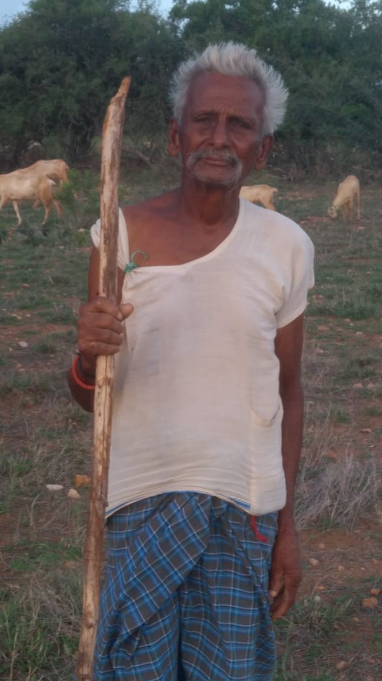
Livestock Keeper address : Ellai Thottam,
Palanigoundan Valasu,
Nallampalayam Post,
Tharapuram Taluka,
Tirupur district-638 661.
Cell : 94860 55094
Total Land Area Owned : 19 acre
Korangadu Land : 12 acre
No. of livestocks : Cows 4 (Kangeyam Breed), Sheep 45
Name of Grass Species in Korangadu : Kolukkottai pul, Thathara, Karunkollu,
Sanappu pul, Arisi pul, Savarikodi, Sulli Mulli
Trees found in Korangadu : Velvel, Neem, Voonjal, Palamaram, Kiluvai

Management of Korangadu :
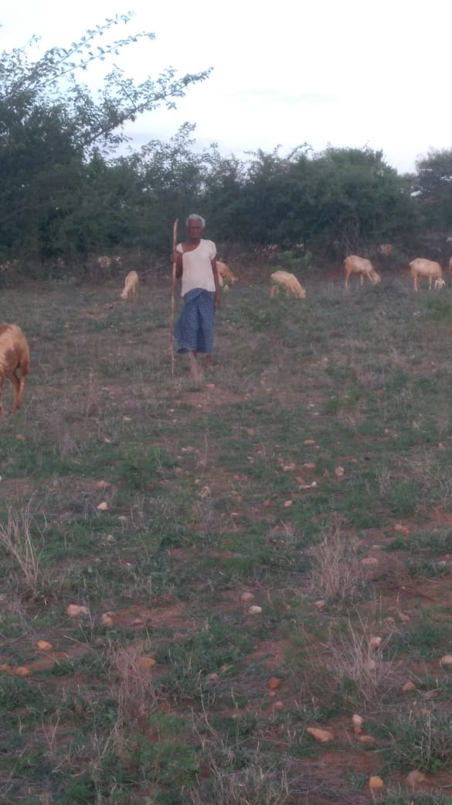
Pruning of trees of Kiluvai, Velvel maram will be undertaken. In the fences Kiluvai will be planted if there is gap in the hedge rows. Stones will be collected and disposed from the field. He earns Rs. 50,000/- from livestock keeping.
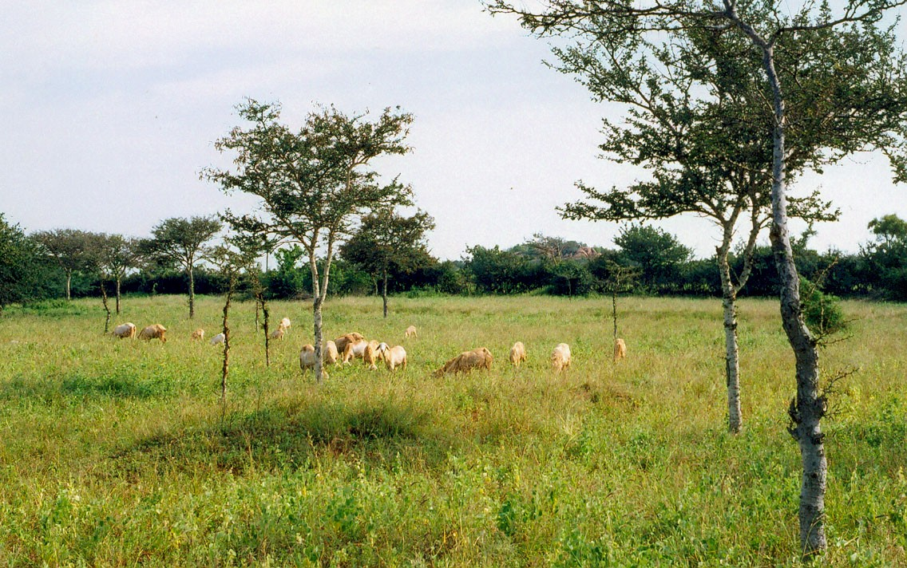
“Korangadu” is a traditional pastureland farming system that exists in semi-arid tracts of Tamil Nadu state in southern India, namely, the Dharapuram, Kangeyam, Palladam, Moolanur and Kallimanthayam areas. Situated in the rain shadow of the Western Ghats, the region receives an annual rainfall of 600-675mm, and the red laterite or gravel type of soil does not allow water stagnation regardless of the amount of rainfall. The majority of the rural population are settled agropastoralists who depend upon livestock.
Individual farmers privately own Korangadu pasturelands and it is estimated that there are over 50,000 individuals with their own paddocks of about 1-2ha size. Approximately 50,000ha of Korangadu pastureland is evident in 500 villages in Erode, Karur, Dindigul and Coimbatore Districts of Tamil Nadu State in southern India. The size of individual paddocks of Korangadu land ranges from 1.5 ha to 10 ha depending upon the wealth status or ownership pattern. Farmers or landless livestock keepers maintain sheep, cattle and buffalo, and Korangadu provides a pasture for their animals and a livelihood for their owners.
Korangadu typically consists of a mixture of grass, legumes and tree species including annual and perennials. It has predominantly three major species of flora which are spatially in three tiers. The lower tier of Kolukattai grass (Cenchrus sp.), an upper tier of tree species including Acacia leucophloea locally called Velvel, and a live fence comprised of a thorny shrub locally called as Kiluvai (Commiphora berryii) makes up the middle tier.

Grazing System
The growth of the grass is evident immediately after the rainfall that occurs during three distinct seasons in this region. About one month is allowed after the rains for the grass to germinate and attain required height and after that animals are taken into the paddock for grazing.
Animals can graze on the Korangadu pasture for at least five months in a year. Besides, different local fodder species grow in such a manner that the pasture is likely to support the partial grazing of animals for at least during 8-10 months in a year. Four hectares of Korangadu pastureland is sufficient to maintain 2 adult cows and 4 calves, or 40 sheep, or 6 buffaloes or 20 goats.
Farmers divide their lands into paddocks, and animals are allowed in rotation. Grazing is permitted from morning till evening. Drinking water fetched from the village and transported by bicycle or bullock cart is available in the stone/cement troughs placed within the paddock. During December-January, if there is good growth of Kolukattai grass a few farmers harvest and store it as hay for feeding the animals during off-season. During summer, the animals are allowed to feed on the pods of Velvel trees.
The Korangadu pasturelands provide opportunities to the livestock for free grazing during October to January continuously due to growth of grass on the receipt of the north east monsoon. During March to June, when there is no grass in the pasture the cattle feed upon the pods of Acacia leucophloea. Whenever summer rains or unseasonal rains occur the vegetation regenerates and this serves as a fodder source for livestock.
The farmers mainly belong to the Gounder’ community and land ownership of individual paddocks ranges from 0.5ha to 10ha. Dairy animals provide income to farmers through moderate milk yield. The community also maintains sheep and goats and earns income from their sale. Farmers who have many paddocks but own few or no livestock lease the land to landless livestock keepers who in turn recieve an annual lease fee of Rs.5000 for 2ha of paddock. Sometimes Korangadu land is given for long term lease basis called Othi to livestock keepers for Rs.30,000 ;whenever the livestock keeper wants to close his grazing contract then he will get back the money without any interest.
The tenure system of Korangadu grazing land is also practiced between owners and tenants when a landless tenant keeps livestock like sheep, for instance, a tenant family pays Rupees 50,000/- (approximately US$ 1,120) for keeping 2ha of paddock and this money is refunded without interest after a period of 2-5 years depending upon the contract.

